Felipe Lopez

PAID SUBSCRIPTIONS business questions

Contents

**Paid Subscriptions Business Questions Dashboard** 2

New Subscription Packages Overall View 4

Metrics: 4

Dimensions: (filter Panes): 4

Charts 4

Packages RAW DATA 5

Annual vs Monthly Subscriptions 5

Dimensions: 5

Metrics: 5

Charts 6

Annual vs Monthly RAW DATA 6

Auto Renew vs Non Auto Renew 7

Dimensions: 7

Metrics: 7

Charts 7

Auto Renew vs Non Auto Renew RAW DATA 8

Data Model Viewer 8

# **Paid Subscriptions Business Questions Dashboard**

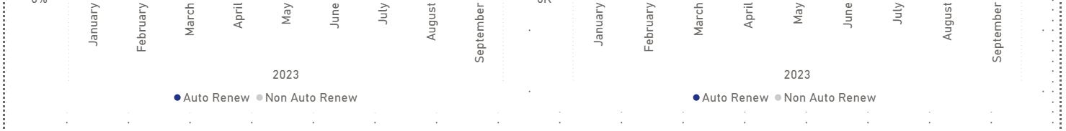

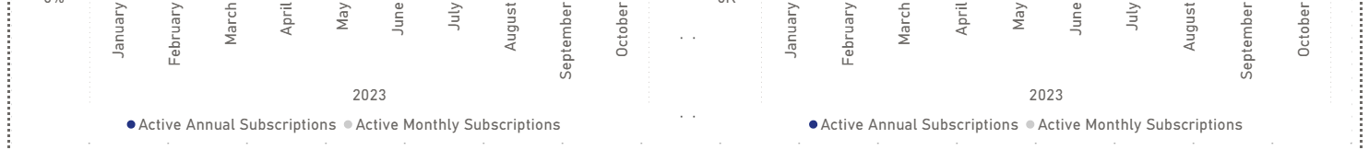

## New Subscription Packages Overall View

### Metrics:

* Total Packages Sold
* OnlyAssistance
* OnlyNavigation
* AssistancePlusNavigation

Parameter for KPI Header rows: Parameter = {

    ("Total Packages Sold", NAMEOF('Packages owners subscribing'[Total Packages Sold]), 0),

    ("Only Assistance", NAMEOF('Packages owners subscribing'[OnlyAssistance]), 1),

    ("Only Navigation", NAMEOF('Packages owners subscribing'[OnlyNavigation]), 2),

    ("Assistance Plus Navigation", NAMEOF('Packages owners subscribing'[AssistancePlusNavigation]), 3)

}

### Dimensions: (filter Panes):

* FullDate as Year
* FullDate as Month
* brand

### Charts

#### Active Packages Share

Dimensions:

* FullDate in Year & Month

Metrics:

* OnlyAssistance
* OnlyNavigation
* AssistancePlusNavigation

#### Active Packages Volume

Dimensions:

* FullDate in Year & Month

Metrics:

* OnlyAssistance
* OnlyNavigation
* AssistancePlusNavigation

## Packages RAW DATA

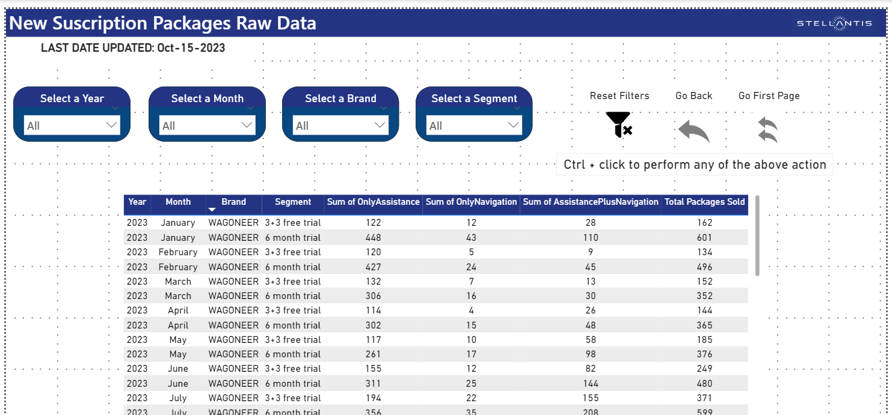

## Annual vs Monthly Subscriptions

### Dimensions:

* FullDate in Year & Month
* brand
* free_trial_flag

### Metrics:

* vincount
* Active Annual Subscriptions = CALCULATE(SUM('Annual-monthly'[vincount]),'Annual-monthly'[Currentterm] = 12)
* Active Monthly Subscriptions = CALCULATE(SUM('Annual-monthly'[vincount]),'Annual-monthly'[Currentterm] = 1)
* Parameter for KPI Header Rows: Parameter 2 = {

    ("Total Active Subscriptions", NAMEOF('Annual-monthly'[vincount]), 0),

    ("Total Active Annual Subscriptions", NAMEOF('Annual-monthly'[Active Annual Subscriptions]), 1),

    ("Total Active Monthly Subscriptions", NAMEOF('Annual-monthly'[Active Monthly Subscriptions]), 2)

}

### Charts

#### Active Packages Share

Dimensions:

* FullDate in Year & Month

Metrics:

* Active Annual Subscriptions
* Active Monthly Subscriptions

#### Active Packages Volume

Dimensions:

* FullDate in Year & Month

Metrics:

* Active Annual Subscriptions
* Active Monthly Subscriptions

### Annual vs Monthly RAW DATA

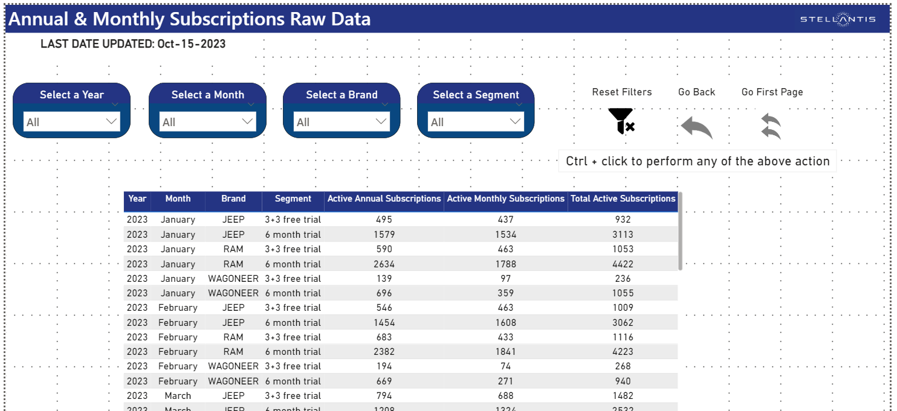

## Auto Renew vs Non Auto Renew

### Dimensions:

* FullDate in Year & Month
* Free_trial_flag
* brand

### Metrics:

* Auto Renew + Non Auto Renew = SUM('Annual AR vs NON AR'[vinCountAR]) + SUM('Annual AR vs NON AR'[vinCountNonAR])
* vinCountAR
* vinCountNonAR

### Charts

#### Auto Renew vs Non Auto Renew Contribution

Metrics:

* vinCountAR
* vinCountNonAR

#### Auto Renew vs Non Auto Renew Volume

Metrics:

* vinCountAR
* vinCountNonAR

### Auto Renew vs Non Auto Renew RAW DATA

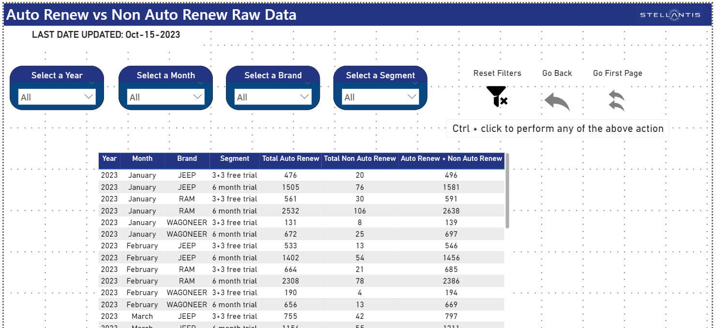

## Data Model Viewer

The Data Model doesn’t show any relational model as the Sources are all unique CVS files for each view.